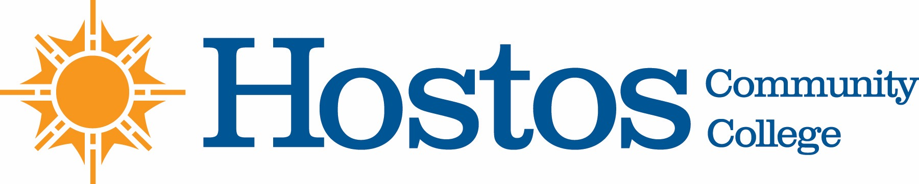

COLLEGE-WIDE CURRICULUM COMMITTEE
AGENDA
TUESDAY, FEBRUARY 25, 2020

- Acceptance of Agenda

- Announcements

- Minutes of Tuesday, February 4, 2020

- Curriculum Items:
Humanities
New Courses
DD 100—Foundation Drawing
FRE 117—French for Heritage Speakers

Humanities
Program Revision
A.A.S. Degree in Digital Design and Animation (Animation Track)
A.A.S. Degree in Digital Design and Animation (Design Track)
A.A.S. Degree in Game Design

- Other Business

