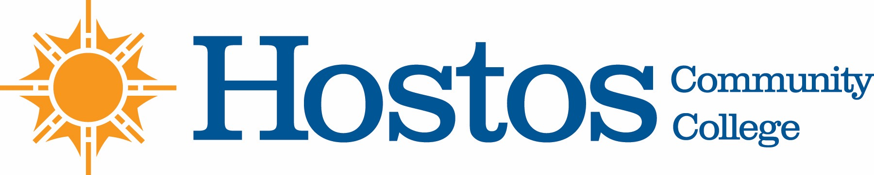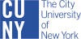

COLLEGE-WIDE CURRICULUM COMMITTEE
AGENDA
TUESDAY, NOVEMBER 5, 2019

- Acceptance of Agenda

- Announcements

- Minutes of Tuesday, May 7, 2019

- Curriculum Items:
English
New Course
ENG 10 Accelerated Writing Skills

Mathematics
New Course
MAT 150SI College Algebra with Trigonometric Functions

- Other Business

