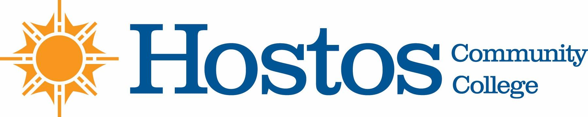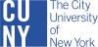

Academic Standards Committee

AGENDA

Monday – October 30, 2023 @ 4 pm

- Election of Chair
- Student Appeal by K.G.

Student seeks to appeal three grades from Fall 2019:

XRA 110 | Radiograph 1 | Prof. M. Livingston | Grade – C  (73.2%)
XRA 112 | Radiologic Physics | Prof. S. Arya | Grade – D  (65.6%)
XRA 114 | Professional Practice Issues in Diagnostic Imaging | Prof. R. Chelladurai | Grade – C (74.15%)

