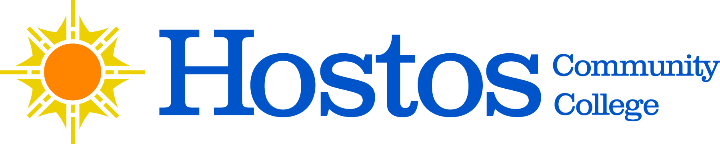

COLLEGE-WIDE SENATE
GENERAL MEETING
Savoy Multipurpose Room
120 East 149th Street (at Walton Ave)
Thursday, December 15, 2022
3:30 – 5:00 PM

SENATE AGENDA

- Call to Order
- Acceptance of Agenda
- Approval of November 17, 2022 Senate Meeting Minutes
- Chair’s Report
- President’s Comments
- SGA President’s Comments
- Curriculum Items – To be voted on
  - Liberal Arts Option
    - Language, Society and Culture Liberal Arts Option-Revision
  - Humanities Department
    - DD 114 – Course Revision
    - BLS 210 – New Course
- Curriculum Items – Informational
  - Flowcharts for ESL, ENG, MAT sequences
- Reports of the Senate Standing Committees
  - Grants
- UFS Update
  - Prof. Julie Trachman
- New Business
- Adjournment

