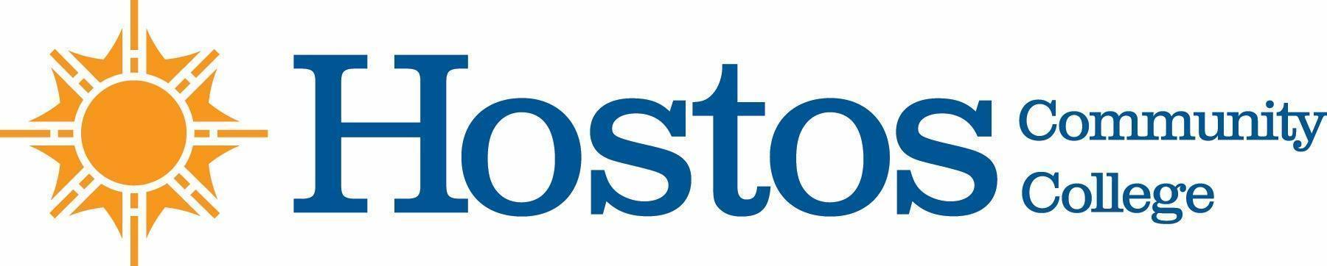

COLLEGE-WIDE CURRICULUM COMMITTEE
MINUTES--Draft
TUESDAY, FEBRUARY 2, 2021

PRESENT: Dean Ann Mester
Ms. Johanna Arroyo Peralta
Ms. Wendy Small - Taylor
Professor Sherese Mitchell
Professor Kathleen Doyle
Professor Isabel Feliz
Professor Edward King
Professor Ana Ozuna
Mr. David Primak
Ms. Silvia Reyes
Professor Anne Rounds
Professor Olga Steinberg Neifach
Professor Lisa Tappeiner

Observers from the Committee on Committees: Profs. Tram Nguyen, Ronette Shaw, Michael Gossett

Professor Tram Nguyen, Chair, Committee on Committees, called the meeting to order at 3:30.

- New Business:

Professor Nguyen confirmed voting members, called for nominations and conducted election of new chair:

Professor Sherese Mitchell was elected Chair of the CWCC

. Discussion of past and current course numbering for VPA 192

- Adjournment:

There being no further business, the meeting of the College-Wide Curriculum Committee was adjourned at 3:55 p.m.

The next meeting of the College-Wide Curriculum Committee is scheduled for Tuesday, February 16, 2021, at 3:30 p.m. via Zoom.

Respectfully submitted,

Professor Lisa Tappeiner

