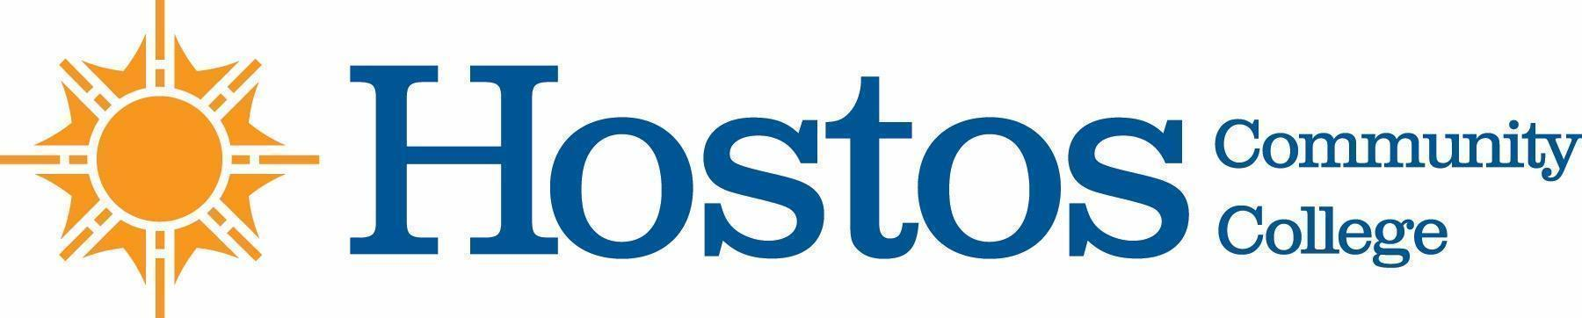

COLLEGE-WIDE CURRICULUM COMMITTEE
MINUTES
TUESDAY, March 2, 2021

PRESENT: Dean Ann Mester
Professor Sherese Mitchell (chair)
Professor Kathleen Doyle
Professor Isabel Feliz
Professor Edward King
Professor Ana Ozuna
Professor Felipe Pimentel
Mr. David Primak
Ms. Silvia Reyes
Professor Anne Rounds
Professor Olga Steinberg Neifach
Professor Lisa Tappeiner

Guests: Profs. Juno Morrow, Ernest Ialongo, Jacqueline DiSanto, Ms. Johanna Arroyo Peralta, Ms. Wendy Small - Taylor

Meeting began at 3:30 pm

- Minutes of Tuesday, February 16, 2021 meeting were approved

- Curriculum Items:
EDUCATION

Course change EDU 226
Vote Results
Yes 11 No 0 Abstain 1
Course change GERO 101 / GERO 103
Vote Results
Yes 12 No 0 Abstain 0

BEHAVIORAL & SOCIAL SCIENCE

Course change CJ 250 -- Tabled until next CWCC meeting
No vote taken

Course change LAW 202
Vote Results
Yes 12 No 0 Abstain 0

Program Revision -- Paralegal
Vote Results
Yes 12 No 0 Abstain 0

HUMANITIES
Course change GD 105
Vote Results
Yes 11 No 0 Abstain 1

NATURAL SCIENCES

Course change BIO 110, BIO 111, BIO 210, BIO 230, CHE 110, CHE 105
Vote Results
Yes 12 No 0 Abstain 0

- Informational Items:

MATHEMATICS
MathEd Articulation

BEHAVIORAL AND SOCIAL SCIENCE
Public Interest Paralegal AAS Pathways
Public Policy and Administration

- Adjournment:

There being no further business, the meeting of the College-Wide Curriculum Committee was adjourned at 4:55 p.m.

The next meeting of the College-Wide Curriculum Committee is scheduled for Tuesday, March16, 2021, at 3:30 p.m. via Zoom.

Respectfully submitted,

Professor Lisa Tappeiner

