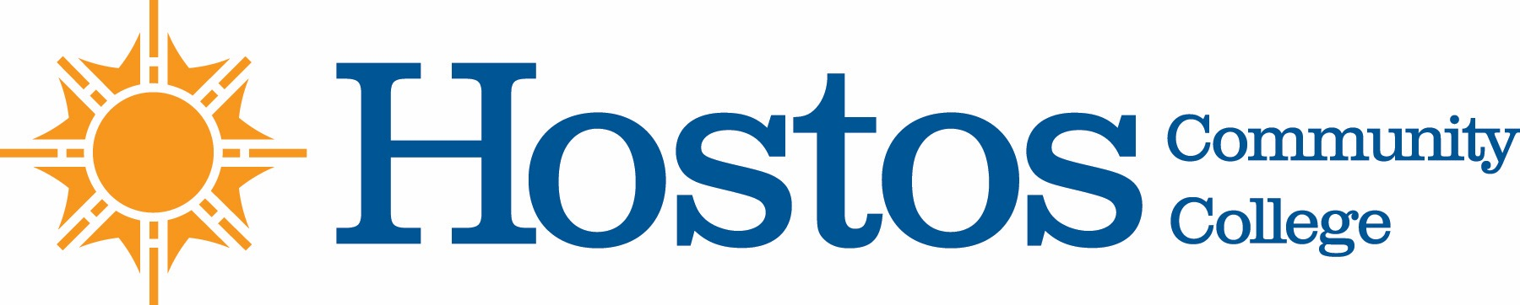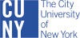

COLLEGE-WIDE CURRICULUM COMMITTEE
MINUTES
TUESDAY, NOVEMBER 19, 2019

PRESENT:
Dean Felix Cardona
Dean Ann Mester
Professor Sandy Figueroa
Professor Drew Hubner
Professor Miriam Laskin
Professor Catherine Lewis
Professor Thomas Mencher
Professor Sherese Mitchell
Professor Olga Steinberg Neifach
Professor Jarek Stelmark

GUESTS: Professor Humberto Ballesteros (Humanities)
Professor Linda Miles (Library)
Professor Matt Moses (English)
Professor Maria Subert (Humanities)
Professor Elisabeth Tappeiner (Library)

STUDENTS: Ms. Salimatou Bah

CALL TO ORDER
Committee Chair Professor Sandy Figueroa called the College-Wide Curriculum Committee meeting to order at 3:35 p.m. in the OAA Conference Room B401

- Acceptance of Agenda
- Announcements
- Minutes of Tuesday, November 19, 2019
- Curricular Items:

Library
New Course
CAP 201 From College to the “Real World”: How Information Works

Vote Results
Yes – 10 No – 0 Abstain – 0
The item passed

p.2

English
New Course
Eng. 241 Introduction to LGBTQ Literature

Vote Results
Yes – 10 No – 0 Abstain – 0
The item passed

Humanities
New Course:
Com 200 Intercultural Communication

Vote Results
Yes – 10 No – 0 Abstain – 0
The item passed

New Course
JPN 101 and JPN 102

Vote Results
Yes – 10 No – 0 Abstain – 0
The item passed

New Course
SPA 223 Literature Humanities in Spanish

Vote Results
Yes – 9 No – 0 Abstain – 1
The item passed

5. Other Business

The meeting ended at 4:20 PM

The next meeting of the CWCC is scheduled for Tuesday, November 26, 2019, in OAA conference room B401.

Respectfully submitted,

Miriam Laskin

