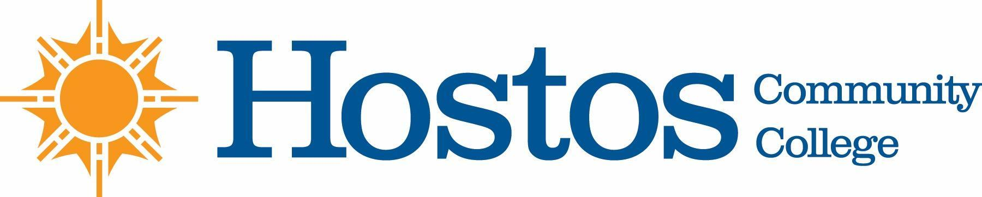

COLLEGE-WIDE CURRICULUM COMMITTEE
MINUTES
TUESDAY, OCTOBER 20, 2020

PRESENT: Dean Ann Mester
Dean Olen Dias
Ms. Johanna Arroyo Peralta
Professor Jacqui DiSanto
Professor Isabel Feliz
Professor Sandy Figueroa
Professor Edward King
Professor Felipe Pimentel
Ms. Joanna Perralta
Mr. David Primak
Professor Anne Rounds
Ms. Wendy Small-Taylor
Professor Olga Steinberg Neifach
Professor Lisa Tappeiner

GUEST: Professor Damaris Lois Lang

Professor Sandy Figueroa, Chair, called the meeting to order at 3:34.

Announcements:
No announcements

Minutes
The minutes of Tuesday, October 6, 2020, were approved as presented.

Discussion
Last spring minor changes to FS 140 course description were recommended at the Senate. It is unclear whether the amended description was included in the Spring 2020 AUR. The version of the description appearing in the AUR will be confirmed and discussed at a later meeting if needed.

Points of clarification: Ms. Small-Taylor, Ms. Arroyo-Peralta and Dean Mester send curricular items to CUNY Central for inclusion in AUR after receiving an official email from the Senate.

Any changes to a course description must be approved by the Senate.

Curriculum Items:
Voting Items

Course Revision: FS 220
Vote Results
Yes 10 No 0 Abstain 0
The curriculum item passed

New Course: SCI 100
Vote Results
Yes 9 No 0 Abstain 0
The curriculum item passed

No new business

Adjournment
There being no further business, the meeting of the College-Wide Curriculum Committee was adjourned at 4:17 p.m. The next meeting of the College-Wide Curriculum Committee is scheduled for Tuesday, November 3, 2020, at 3:30 p.m. via Zoom.

Respectfully submitted,

Professor Lisa Tappeiner

