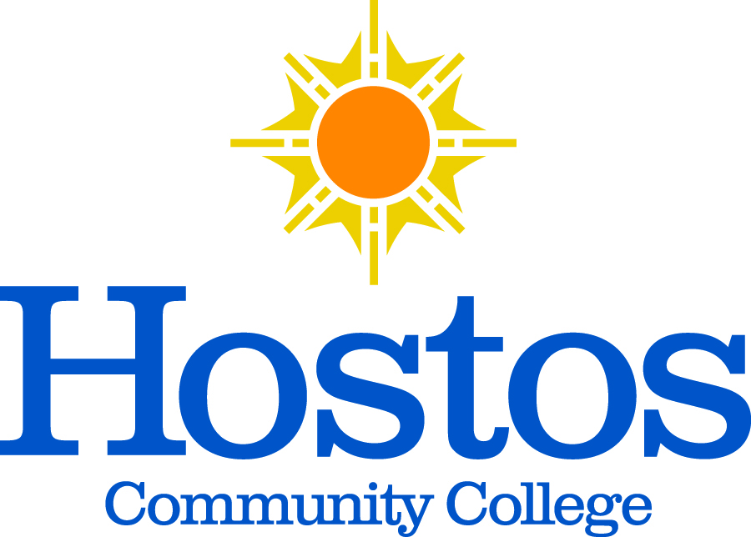

Minutes for the Committee on Committees

Date and Time: Monday, April 12, 2021 | 03:30 PM-04:08 PM
Location: Zoom Conference Call

Presiding: Tram Nguyen
Present: Michael Gosset, Alba Lynch, Debasish Roy, Ronette Shaw, Julie Trachman, Brian Carter.
Absent: Nancy Genova, Hatem Anaam

Minutes Prepared By: Debasish Roy

Topic | Discussion | Decision / Action
Meeting to Order: 03:35 PM  Presentation and  Acceptance of minutes  Acceptance of Agenda | Motion to accept the Minutes of March 8th.  Start discussion on topics of Agenda. Motion to accept the Agenda by raising hands. | Seconded. Minutes approved with minor changes and no objections.  Unanimous approval.
Chair’s Remark: | End of the year reports will be updated and sent out to all Chairs of Senate Standing Committees, due by May 17, 2021.  SGA President Carter suggested that he receive the documents as well.  Three committees to report at Senate this month, leaving two committees left in May.  President-created “Community Advisory Council” will report to the senate.  Next month there will be an election to select new Chair(s) of C-O-C as current Chair will be away on Fellowship Leave.  Chair will work with SGA President Carter to ensure that SGA list of committee representatives is updated. | Committee members agreed with this suggestion approvingly.
Certifications  New business | Certification of Andrew Connolly for Elections Committee.  SGA President Carter stipulated that there is a chance that Governor Cuomo allocate Cares Act money to allow much of CUNY tuition to be free for next three years. So, we will promote for more enrollment. It will start from the coming Fall ’21. | Unanimous approval.
Adjournment | Motion to adjourn made at 04:08 PM. Seconded. | Unanimous approval

