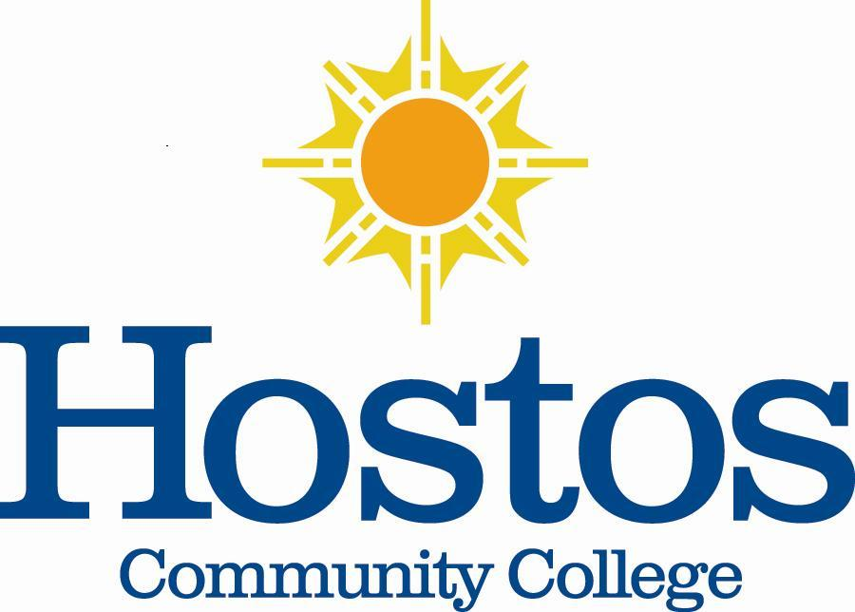

Institutional Research Committee
Hostos Community College/The City University of New York
475 Grand Concourse
Bronx, New York 10451

MINUTES

February 25, 2021, 3:30 p.m.
Meeting Location: Zoom

Members Present: Hatem Anaam, Jason Buchanan, Marcella Bencivenni, Eliana Cabral, Helen Chang, Soheli Choudhury, Denise Cummings-Clay, Michel Portela, Emily Tenzer Sautoro, & Victor Torres-Velez / Absent: Piotr Kocik

- Call to Order – Dr. Jason Buchanan, Institutional Research Committee (IRC) Chair (2020-2021), called the meeting to order at 3:35 p.m.

- Minutes – Dr. Buchanan solicited changes to the Minutes of 12/16/2020. One correction was made to page 2. Advising students by the census date was changed to mid-February. The Minutes were approved by acclimation with this change.

- Updates – Any updates are to be provided at the next meeting.

- Student Retention – Dr. Buchanan opened the discussion regarding developing a document to guide the committee in exploring student retention at Hostos. He indicated that the resulting document can be presented to the college Senate for information. Additionally, he expressed the value of the document’s usage in IRC members’ portfolios to reflect the deliberations of the IRC. The committee engaged in a discussion regarding student retention. Topics that could better inform student retention at Hostos were identified. The first draft of the one-page document is attached to these Minutes.

- Next Meeting – The next meeting will be held on Thursday, March 25, 2021, 3:30 p.m. via Zoom. Dr. Buchanan plans to invite Carlos Rivera, Director of Admissions & Recruitment, and Carlos Guevara, Director of Educational Technology, to the next meeting to shed insight on the student retention topic.

- Adjournment – The IRC meeting adjourned at 4:54 p.m.

Respectfully submitted,
Denise Cummings-Clay, Ph.D., Secretary, IRC
Institutional Research Committee
A View of Student Retention at Hostos Community College/CUNY
2020-2021
Student Retention Defined:

- Broad Strokes Data
- Key Markers of Data for Retention
- Full-time, first year students
- Majors in Disciplines (Markers of similarities and differences)
- Other Demographic Data (including zip codes?)
- Adult Demographic Data (Traditional Population versus Non-traditional Population)
- Graduation Data (i.e., Transfer within CUNY, Transfer to Senior College, etc.)
- Placement Data (i.e., English, Math, and writing) – multiple-source proficiency data.
- Student technology capacity (i.e., equipment, navigation of internet and/or Blackboard, etc.)

- Blackboard Usage (i.e., Student log-in rate)

- Administrative Concerns and Issues/Touch Points
- Alignment of Advisement Channels of communication (faculty and administration)
- eLumen (Data gathering assessment tool for faculty usage)
- SUCCEED (Data gathering reflecting student engagement in courses)
- Channels of communication (unity of thought)
- Student ability to pay (i.e., Bursar holds, lack of personal funds, etc.)
- Student awareness of the different types of teaching modalities and their knowledge about the types

- Trends – How Faculty are Addressing Student Retention
- Teaching Modality
- Asynchronous
- Synchronous
- Face-to-face
- Student engagement tools
- First-year Seminar (i.e., Degree completion percentage rates compared to percentage rates achieved prior to offering First-year Seminar)

- Conclusion
- Models
- At Hostos

