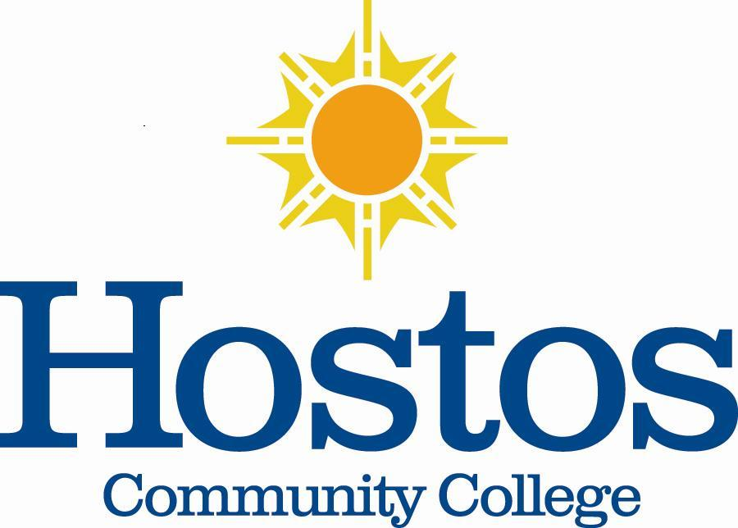

Institutional Research Committee
Hostos Community College/The City University of New York
475 Grand Concourse
Bronx, New York 10451

MINUTES

March 25, 2021, 3:30 p.m.
Meeting Location: Zoom

Members Present: Jason Buchanan, Eliana Cabral, Helen Chang, Denise Cummings-Clay, Piotr Kock, Michel Portela, & Victor Torres-Velez / Absent: Hatem Anaam, Marcella Bencivenni, Soheli Choudhury, Emily Tenzer Sautoro / Guest: Carlos Rivera, Director of Admissions and Recruitment

- Call to Order – Dr. Jason Buchanan, Institutional Research Committee (IRC) Chair (2020-2021), called the meeting to order at 3:33 p.m. The meeting was informational since there was no quorum. Dr. Buchanan provided background to Carlos Rivera, guest, regarding the committee’s focus to develop an informational document that can be presented to the Senate regarding student retention. The document is designed to highlight student retention issues, share actions in which Hostos is engaged to address the issues, and to offer suggestions that might help alleviate the issues identified.

- Minutes – Dr. Buchanan indicated that the Minutes of 2/25/2021 would be circulated to the committee via email for approval.

- Student Retention – Dr. Buchanan displayed on the screen the topics developed by the committee at the IRC meeting of 2/25/2021. The topics presented are categorized into four areas: (1) Broad-stakes data, (2) Administrative concerns and issues/touch points, (3) Trends regarding how faculty are addressing student retention, and (4) Conclusion. Dr. Buchanan presented Carlos Rivera, guest.

Mr. Rivera expressed a concern regarding where students could learn about the definitions for the various teaching modalities, and whether students really understood the differences of the modalities. It was noted that this information might be listed in the registration portal. However, a definitive location was not given. Mr. Rivera shared that many students seem to be confused about the modalities when they call the Admissions Office for assistance.

Mr. Rivera represented the Admissions and Retention Senate Committee. He shared that an Admissions Student Retention Career Fair was held on March 18, 2021. Other student retention strategies underway include the development of a Communications Plan for students to include academic programs, academic support services, athletics, student services, HALC, and information sessions of new student activities. Each plan ends with an appeal indicating that Hostos is open for admissions, how to apply, etc.

Mr. Rivera highlighted the work on a Counselor Communications Plan to high school counselors. The template has been developed regarding the type of communication that needs to be disseminated. He shared that the first communication would go out shortly from Interim Provost Drago to highlight majors at Hostos. April 19, 2021 is the deadline for all communications plans. Mr. Rivera indicated that the plans can be shared with the IRC after they are complete.

Mr. Rivera suggested adding a topic to the IRC’s list of research topics – The Zip Codes of which Hostos students reside.

A discussion arose regarding why students attend Hostos versus Bronx Community College. It was noted that when conducting student recruitment, Hostos highlights those programs that are unique to Hostos and not to other colleges. Specialized academic programs and unique experiences at Hostos are featured as reasons to attend Hostos. Moreover, it was stressed that Hostos’ location is a transportation hub (149th Street & Grand Concourse), which is helpful for student access.

Another issue raised was that sometimes students who are readmitted attend one semester and leave Hostos the next. It was noted that although the Admissions Office does much outreach to students, many of the students are looking to complete a bachelor’s degree and transfer. It was clarified that CUNY has no mechanism in place to prevent students from transferring to other colleges early.

A question arose regarding whether Hostos has data regarding where students go after they leave Hostos. Piotr Kock clarified that students usually transfer to Lehman College, John Jay Community College of Criminal Justice, Hunter College, City College, and Baruch College. Hostos has articulation agreements with Lehman and John Jay.

It was pointed out that research had not been done regarding where students go if they attend Hostos for one semester. It was noted that some students have a gap in enrollment for as much as two years.

A discussion arose regarding the difference between course equivalence and Pathways. It was clarified that course equivalence is determined by faculty in the respective departments and that it is more important to focus on this rather than Pathways. It was noted that course equivalency is handled differently at the different campuses and is a struggle for students. Also, it was noted that this is a problem since articulation agreements are not updated frequently. It was stressed that students need to know what they can do upon graduation. Thus, it was noted that course equivalency, especially with colleges in which Hostos has an articulation agreement, might be a topic that faculty in multiple disciplines might want to consider assuring the transferability of students to those colleges and benefit from having attended Hostos.

- Next Meeting – Dr. Buchanan will contact members of the IRC regarding plans for the next meeting.

- Adjournment – The IRC meeting adjourned at 4:27 p.m.

Respectfully submitted,
Denise Cummings-Clay, Ph.D., Secretary, IRC
Institutional Research Committee

A View of Student Retention at Hostos Community College/CUNY – 2020-2021

(Revised: 3/25/2021)

Student Retention Defined: To help students to matriculate successfully in courses, remain in school, and progress toward their academic and professional goals.
- Broad Strokes Data
- Key Markers of Data for Retention
- Full-time, first year students
- Majors in Disciplines (Markers of similarities and differences)
- Other Demographic Data
- Adult Demographic Data (Traditional Population versus Non-traditional Population)
- Graduation Data (i.e., Transfer within CUNY, Transfer to Senior College, etc.)
- Placement Data (i.e., English, Math, and writing) – multiple-source proficiency data.
- Student technology capacity (i.e., equipment, navigation of internet and/or Blackboard, etc.)
- Blackboard Usage (i.e., Student log-in rate)
- Zip Codes of Students admitted to Hostos

- Administrative Concerns and Issues/Touch Points
- Alignment of Advisement Channels of communication (faculty and administration)
- eLumen (Data gathering assessment tool for faculty usage)
- SUCCEED (Data gathering reflecting student engagement in courses)
- Channels of communication (unity of thought)
- Student ability to pay (i.e., Bursar holds, lack of personal funds, etc.)

- Trends – How Faculty are Addressing Student Retention
- Teaching Modality
- Asynchronous
- Synchronous
- Face-to-face
- Student engagement tools
- First-year Seminar (i.e., Degree completion percentage rates compared to percentage rates achieved prior to offering First-year Seminar)

- Conclusion
- Models
- At Hostos

