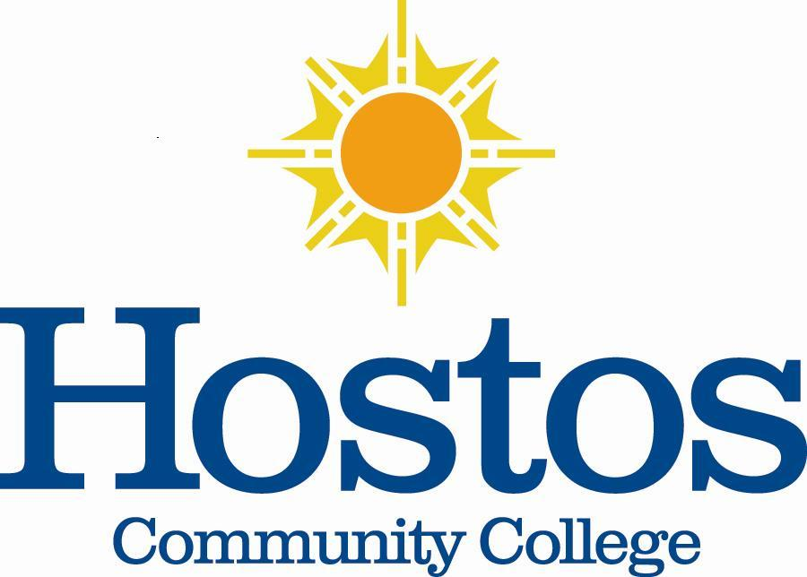

Institutional Research Committee

Hostos Community College/The City University of New York
475 Grand Concourse
Bronx, New York 10451

MINUTES

October 23, 2020, 2:00 p.m.
Meeting Location: Zoom

Members Present: Jason Buchanan, Eliana Cabral, Helen Chang, Soheli Choudburry, Denise Cummings-Clay, Michael Pertela, Emily Tenzer Sautaro, & Victor Torres-Velez Members Absent: _____________________

- Call to Order – Dr. Jason Buchanan, Institutional Research Committee (IRC) Chair (2019-2020), called the meeting to order at 2:00 p.m.

- Introductions – Dr. Buchanan asked each member present to introduce themselves. Each person gave their name, title, and department in which they served.

- Committee Mandate – Dr. Buchanan shared with the committee its Charge as written in the charter:

- The committee will facilitate research bearing on College educational programs and retention. To that end, it will assist research conducted in the College in compliance with the provisions of the Committee on Human Subjects, request data on behalf of research projects, recommend that studies be undertaken, submit all recommendations for research to the full Senate for approval, and disseminate results to the College community.
Discussion ensued regarding possible activities for which the committee could engage. One suggestion was acquiring data to support decisions made by the Office of Academic Affairs. It was noted that the IRC could request specific data from the Office of Institutional Research to analyze topics of concern. It was clarified that publications on research being done by the IRC for Hostos would not require Institutional Review Board approval.

A question arose regarding whether the committee could design its own methods of research. The response was yes. Another suggestion offered for consideration was to consult with the Hostos Co-Chairs (Nelson Nunez and Kate Wolfe) for the Middle-States Self-Study to possibly identify whether the Self-Study had revealed areas where research or data was needed to support recommended improvements in the college or to assess effectiveness in processes. Other ideas for research offered were in the areas of student retention, faculty retention, or adjunct faculty retention.

In summation, it was clarified that recommendations of the IRC regarding research are to be submitted to the college’s Faculty Senate for voting.

- Election of IRC Leaders – Two elections were held. The first election was for IRC Chair. The second election was for IRC Secretary.

Jason Buchanan was nominated for IRC Chair. No other nominations were made for the office. The IRC voted unanimously in favor of Jason Buchanan (Associate Professor in the English Department) to serve as IRC Chair for the 2020-2021 academic year.

Denise Cummings-Clay volunteered to serve as IRC Secretary if there were no other nominations. No other nominations were made for the office. The IRC voted unanimously in favor of Denise Cummings-Clay (Assistant Professor in the Education Department) to serve as IRC Secretary for the 2020-2021 academic year.

Dr. Buchanan described the duties of each office for clarity.

- Next Meeting – Possible days and times for the next meeting to be held in November 2020 were discussed. Some preferences were identified. Dr. Buchanan will send out a doodle poll within the next three business days with a variety of days and times. Members are to indicate their preferences. Dr. Buchanan then will schedule the next meeting time and schedule for the remainder of the academic year.

To prepare for the next meeting, Dr. Buchanan requested that members think about what they believe the IRC should set as goals/activities during this academic year. The next meeting is to consist of this topic so that the direction of the IRC for the year can be set.

- Adjournment – With no further business to come before the IRC, the meeting adjourned at 2:45 p.m.

Respectfully submitted,

Denise Cummings-Clay, Ph.D., Secretary, IRC

