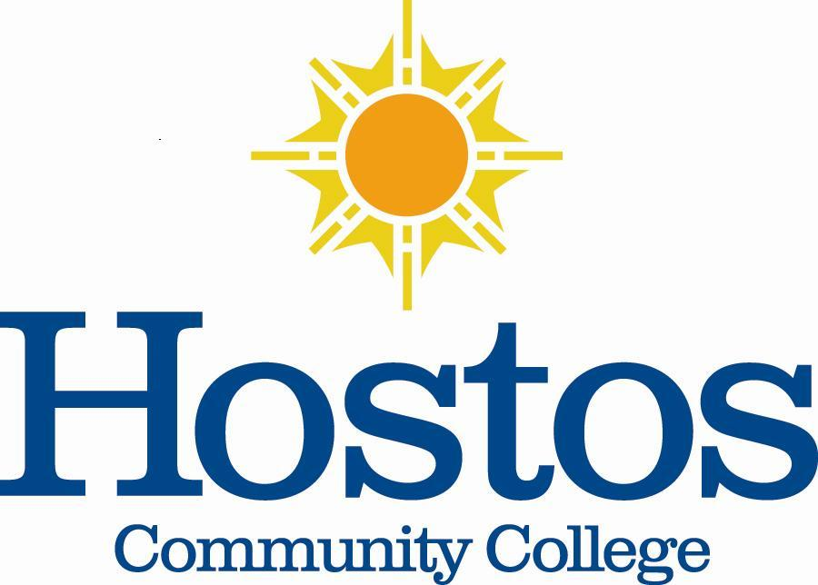

Institutional Research Committee

Hostos Community College/The City University of New York
475 Grand Concourse
Bronx, New York 10451

MINUTES

December 16, 2020, 3:00 p.m.
Meeting Location: Zoom

Members Present: Jason Buchanan, Marcella Bencivenni, Helen Chang, Soheli Choudhury, Denise Cummings-Clay, Piotr Kocik, Michel Portela, Emily Tenzer Sautoro, & Victor Torres-Velez
Absent: Eliana Cabral

- Call to Order – Dr. Jason Buchanan, Institutional Research Committee (IRC) Chair (2019-2020), called the meeting to order at 3:05 p.m. He asked each member to introduce themselves to the other committee members.

- Minutes – Dr. Buchanan asked if there were any changes to the Minutes. By common consent, the document was approved with correction to the spelling of some names of members.

- Goals

- The IRC Charge indicated in the Charter is as follows: The committee will facilitate research bearing on College educational programs and retention. To that end, it will assist research conducted in the College in compliance with the provisions of the Committee on Human Subjects, request data on behalf of research projects, recommend that studies be undertaken, submit all recommendations for research to the full Senate for approval, and disseminate results to the College community.
A discussion ensued regarding specific areas to consider for IRC goals next spring. Suggestions for topics included:

- Student Retention – It was indicated that data is currently collected regarding Gateway courses. Graphs regarding retention metrics at Hostos were shared. Mr. Kocik suggested that IRC could analyze student retention data findings since Hostos is working on increasing the number of students graduating. It was noted that there was no magic fix and that the hardest component to include was the student’s input.

It was stressed that the issue of retention was key. Worry was expressed regarding the downward trend of student retention. Some concern was raised regarding why students who had attended Hostos a year ago were not returning.

This discussion concluded that some analysis was needed regarding advising. It was noted that the Hostos model does not seem to be working. A more direct model of advising was suggested. Strategies offered were faculty-direct advising and assigning a faculty advisor to students that would be listed on faculty course rosters each semester. It was shared that faculty could better shape the conversation with students and it would save advisement steps. In sum, the suggestion was to investigate effective ways for advising units and the faculty to help students.

Mr. Kocik suggested two quick fixes to help faculty with advisement functions:

- Share-point folder. Faculty were urged to request this information from the respective Department Chairs regarding the uploaded list for each department of individual courses with lists of students and contact information.
- Advise students by the census date (mid-March), indicating the student assigned to each advisor.

- Mid-semester Evaluation Checkup – This strategy was recommended for usage to determine how students are performing in classes.

- Blackboard Usage – The focus would be on student lag with assignments and rationale for the lag.

- COVID-19 Impact on Student Enrollment

Mr. Kocik asked if there was an IRC member who would consider working with him in January 2021 to do a case study regarding classes. Michel Portela volunteered.

Some facts offered to the IRC to help members during deliberations were:

- Surveys indicated that students leave the college because of bureaucracy. Another contributing reason indicated was that life happens.
- Hostos has about 100 advisors in many different areas. ASAP is more evenly spread regarding the number of students per advisor. A manageable load per advisor is about 150-160 students.
- The Hostos retention rate is going down. It is a problem across the board. Four-year schools are stable right now.
- The decline is also connected to the changes in admission CUNY-wide, as students now can enter senior colleges directly.

ACTION: By common consent, the IRC determined that student retention should be its focus for next spring (2021). The IRC plans to align advisement principles with faculty advisement principles. Also, the IRC might explore the idea of proposing to the Senate a 30-day check-in for students.

PROCESS – It was concluded that the IRC would request data and analyze it. The outcome suggested was to develop a one-page document to be presented to the Senate to highlight the issues IRC is finding to help facilitate productive dialogue. IRC recommendations regarding research are to be submitted to the college’s Faculty Senate for voting.

A question arose regarding whether the IRC was an advisory committee, whether the IRC could come up with clear proposals for change, or whether the IRC should respond to work that the college is doing. The response was that the IRC should be an active force recommending appropriate fixes to problems that the IRC identifies as problems. The IRC Chair stressed that as the IRC proposes possible solutions to problems, IRC operating in this fashion does not put any committee member on the hook to resolve the problem.

- Next Meeting – Dr. Buchanan, IRC Chair, will send a doodle poll to IRC members in early 2021 to determine their meeting availability. The next meeting then will be scheduled appropriately.

- Adjournment – With no further business to come before the IRC, the meeting adjourned at 4:23 p.m.

Respectfully submitted,

Denise Cummings-Clay, Ph.D., Secretary, IRC

