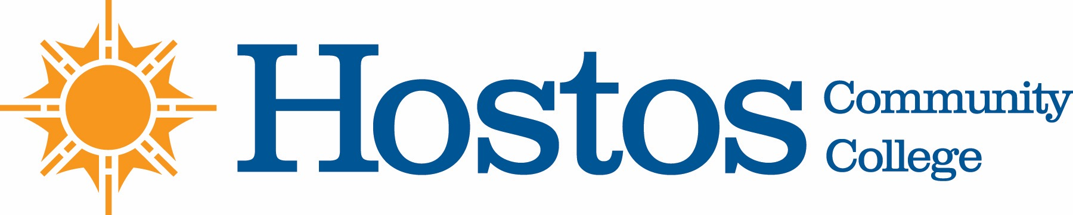

COLLEGE-WIDE CURRICULUM COMMITTEE
AGENDA
TUESDAY, APRIL 2, 2019

- Acceptance of Agenda

- Announcements

- Minutes of Tuesday, March 26, 2019

- Curriculum Items:
HUMANITIES
Digital Media
New Course: GD 110
Course Revision: GD 201
Program Revision GD

Course Revision: DD 107
DD 108
DD 111
DD 201
DD 207
DD 250

Course Revision: DM 201
DM 202
DM 205
DM 206

Latin American and Caribbean Studies
New Course: LAC/WGS 260

COMM
New Course: COM 200

BEHAVIORAL/SOCIAL SCIENCES
New Course: PSY 170

LIBERAL ARTS
Liberal Arts Option 1
Liberal Arts Option 2

- Other Business

- Adjournment

