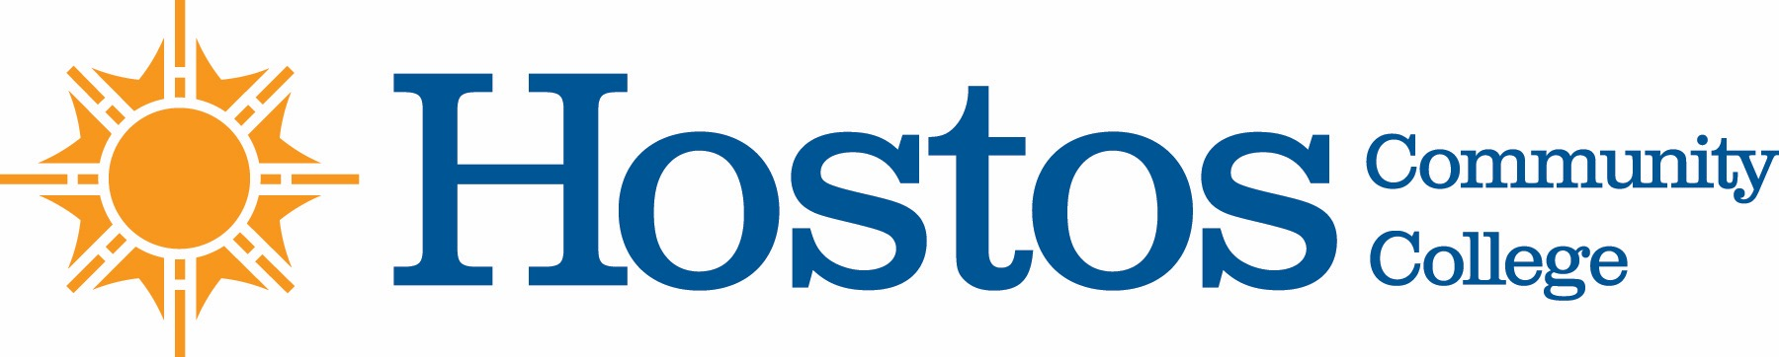

COLLEGE-WIDE CURRICULUM COMMITTEE
AGENDA
TUESDAY, OCTOBER 20, 2020

- Acceptance of Agenda

- Announcements:

- Minutes of Tuesday, October 6, 2020

- Curriculum Items:
Natural Sciences
Course Revision: FS 220

New Course: SCI 100

- Other Business

