Hostos Community College
Microsoft Office 365 Education (For Students)
Technology Services » For Students

Downloading and Installing Microsoft Office365
The City University of New York provides Microsoft Office 365 for Education to students at participating colleges via the Microsoft Office in Education program. The license remains active until you leave the University, at which point it will be in read-only mode and you will be prompted to pay a license fee to Microsoft or stop using Microsoft Office 365 for Education.
Please review the Acceptable Use of University Data in the Cloud Policy before storing, synching, and/or sharing data in any of cloud service, including Microsoft Office 365 for Education. The following table summarizes what data can be stored so data is protected from unauthorized access.
Note: Guide assumes you have setup Multi-Factor Authentication for M365.
1. Go to: https://www.office.com 2. Click on "Sign In".
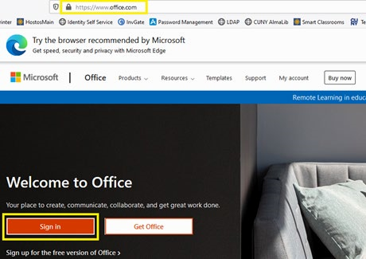

- Enter your CUNYfirst login name (firstname.lastname00@login.cuny.edu) in the email address field and click "Next".
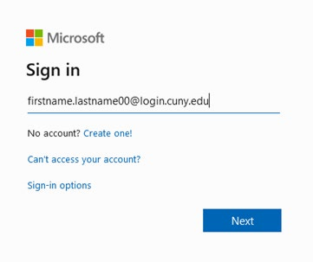

- At the CUNY Web Applications Login page, enter your CUNYfirst login and password and click on "Login".
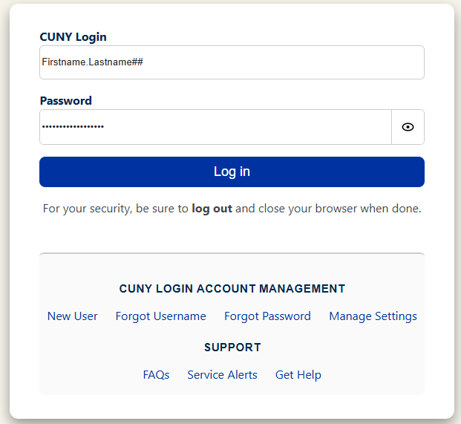
- Enter the authentication code
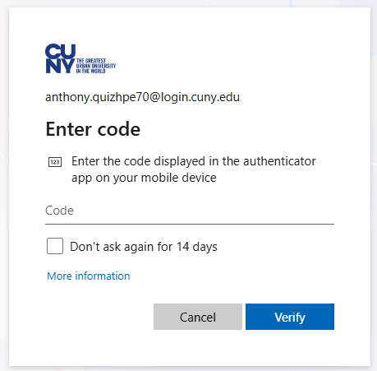

- Choose "Yes" or ""No" to continue.
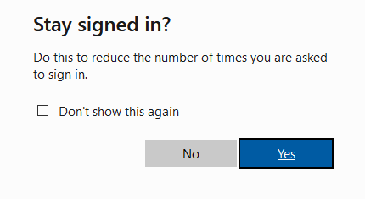
7. Click on “Apps”
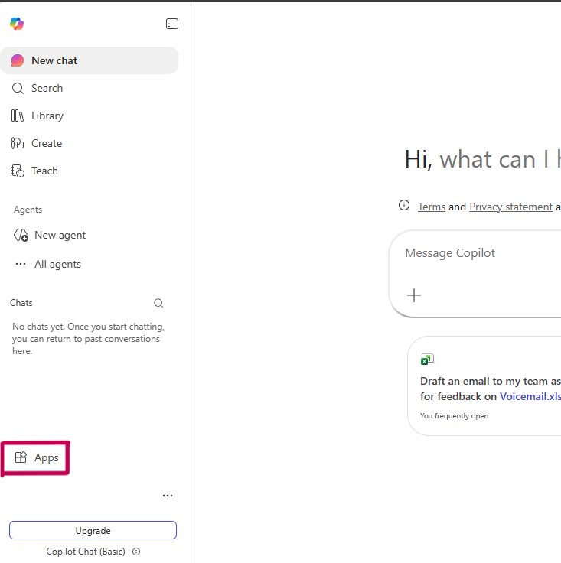
- From the top right of the screen, click on "Install Office".

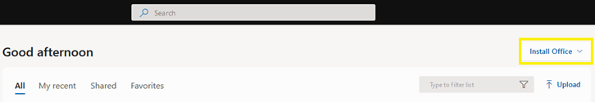
- Then click on "Office 365 Apps" to download and installer.
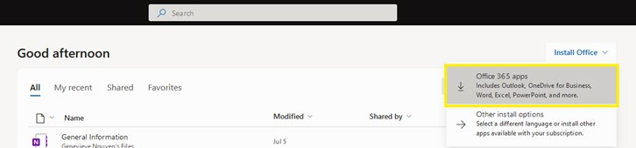
- Click on "Save File" when prompted.
- Go to your "Downloads" folder once the download is completed.
- Double-click on the installer and follow the prompts to complete the installation of the Microsoft Office Apps.

